Classical Solutions of Ordinary Differential Equations

Software Patch Development for

Blackhawk Helicopter Surveillance Receivers

Author: Carlos Lazo

Team: MCCCXXXVII

Team Leader: Colin Fischer

Team Members:

Carlos Lazo

Carolyn Andrews

Colin Fischer
Michael Doran

Course: Classical Solutions of Ordinary Differential Equations

Instructor: Dr. Karl Brommer

Individual Hours: 9 hours

Group Hours: 9 hours

Date Submitted: 09/15/2008

Executive Summary

Problem

A foreign military group has been communicating with modified High Frequency (HF) Single Side Band (SSB) radios. The radios emit signals that are difficult to sense using a key click mode and can protect against interference by transmitting in a Continuous Wave (CW) mode. This report analyzes the development and overall effectiveness of a software patch for surveillance receivers on Blackhawk helicopters. The patch correlates a reference waveform to the key click transmission frequency radiated by the foreign radios in an effort to successfully intercept enemy communication. The analysis compares the sensitivity of a 100-ms pulse detector to the developed software patch in a correlation detector.

Method of Analysis

The differential equations for an RLC circuit used in modeling a captured enemy radio accurately provide insight to the problem at hand. Given the values of all electrical components and the system’s initial conditions, the differential equation of voltage across the capacitor is used to identify key system parameters and values. We analyze the capacitor because its voltage level is amplified through an ideal RF power amplifier, evoking a signal transmission through the enemy radio’s antenna network. The newly acquired information sets a solid mathematical foundation for the development of the software patch in key-click mode.

The Mathcad 14 and MATLAB R2008 software packages provide an effective simulation environment for our software patch development. Having derived the differential equation modeling enemy radio transmissions, we make a comparison to signal with a shorter pulse time with our patch. This should improve overall signal detection and range. We then reanalyze the paramilitary system, replacing the key-click switch with an oscillator to account for the CW mode. Maximum gain and operational bandwidth calculations are made for this analysis.

Results / Recommendations

In order to detect enemy signals in key-click mode, the Blackhawk surveillance receiver uses a 100-ms pulse time. Our group’s investigation shows that with the installation of our software patch, the Blackhawk would need to listen for 20ms to successfully recognize an enemy key click. The sensitivity of the system increases, allowing the receiver to detect a signal five times weaker than the original signal and increasing the signal detection radius from the Blackhawk by approximately 2.24 times the original radius.

In the CW mode, the group finds that there is a 93.98dB gain in the overall circuit. The resonant frequency of the circuit is at 1.592 MHz. Given these calculations, we determined that the maximum useful tuning bandwidth for the RLC circuit is 55 Hz.

We recommend using our software patch from the conclusions drawn in our analysis.

Table of Contents

Executive Summary 2
Problem 2
Method of Analysis 2
Results / Recommendations 2
Problem Statement 5
Overview 5
System Description 5
Assumptions 6
System Analysis 7
Approach 7
Detailed Analysis 7
Key Click Mode 7
Continuous Wave (CW) Mode 11
Results 12
Results 12
Key Click Mode 12
Continuous Wave (CW) Mode 13
Recommendations 14
References 15
Appendix 16
MATLAB Code 16

List of Figures

Figure (1): HFSSB Front-End Transmitter Circuit Diagram 5
Figure (2): Pulse Detector and Correlation Detector Diagram 6
Figure (3): Magnitude of Signal Squared 9

List of Tables

Table (1): Key Click Mode, Part 1 Results 13
Table (2): Continous Wave (CW) Mode, Part 2 Results 14

Nomenclature

Symbol | Definition | Units
R | Resistor | Ω (Ohm)
L | Inductor | H (Henry)
C | Capacitor | Farad (F)
ω | Frequency | Rad/sec or Hz
ω_{Center} | Center frequency or Natural Frequency | Rad/sec or Hz
I, i(t) | Current | A (Amps)
V(t), E(t) | Voltage | V (Volt)
t | Time | s (Seconds)
s | Eigenvalue | ---
Q | Charge | C (Coulomb)
S(t) | Signal | (V) Volt
N(t) | Noise | (V) Volt
G | Gain | dB

Problem Statement

Overview

Our group is tasked with developing a software patch for surveillance receivers on Blackhawk helicopters monitoring ongoing paramilitary communication. The foreign group uses High Frequency Single Side Band (HFSSB) radios to transmit information. We have obtained the front-end of their radio transmission system and know that it can operate in two modes. The key click mode decreases the probability for signal detection and the continuous wave (CW) mode prevents exploitation.

The software patch we design needs to show a relationship between a reference waveform and radio recordings tuned to the key click transmission frequency. Once developed, we compare our software patch to a correlation detector using a 100ms pulse.

System Description

The HFSSB radio is comprised of an RLC circuit (contains a resistor, capacitor, and inductor) with a switch in key click mode. When the operator transmits the signal, the switch closes, discharging the capacitor in the circuit. The voltage drop through the capacitor is amplified through the ideal RF power amplifier and is then fed to the antenna network. As can be seen in Figure (1), the resistor has a value of 2 ohms (Ω), the capacitor has a value of 1 picofarad (pF), and the inductor has a value of 10 millihenries (mH).

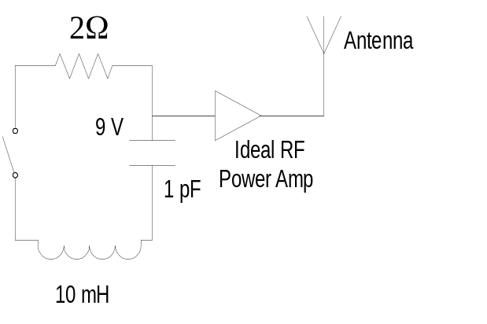
Figure (1): HFSSB Front-End Transmitter Circuit Diagram

In continuous wave (CW mode), an oscillator replaces the switch in Figure (1). This causes the radio to operate in a continuous mode versus a pulsed mode dependant on the discharge of the capacitor. The oscillator will now be responsible for generating a voltage.

A sensitivity comparison is made between a 100ms pulse detector and a correlation detector using our software patch. A visual representation is seen in Figure (2).

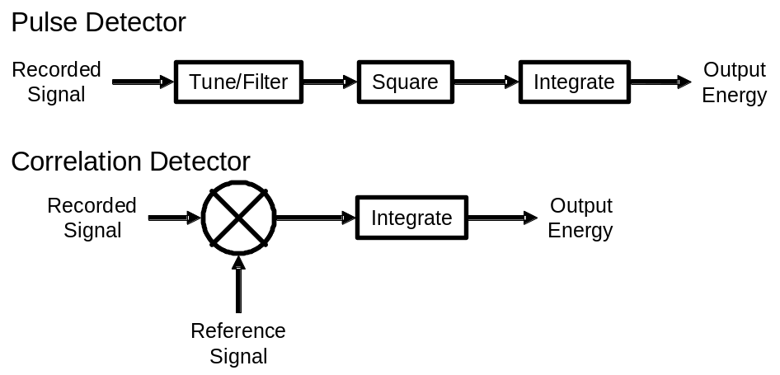
Figure (2): Pulse Detector and Correlation Detector Diagram

Assumptions

- It is assumed that all resistance in entire system is incorporated into the resistive value.
- This is a simplifying assumption due to lack of information. In order to calculate the voltage drop due to the wires, the wire diameter and length would have to be known. Since this is a small circuit, the voltage drop due to the wire would be minimal.
- The charging circuit (not shown) used to charge the capacitor consistently charges the capacitor to 9V between uses.
- This is a simplifying assumption since no information is provided for the charging circuit.
- The noise level assumed for the comparison between the old software and the patched software is constant per unit time.
- This is assumed for comparative purposes.
- Once a pulsed signal has attenuated by 9dB, the pulse can be considered over.
- This allows the majority of signal energy to be captured while minimizing false alarms from other signals with similar front ends.

System Analysis

Approach

The HFSSB radio is modeled as an RLC circuit. Equation (1), Equation (2), and Equation (3) are used to describe the voltage drops across all main components:

Resistor: 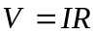 Equation (1)

Inductor: 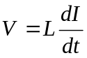 Equation (2)

Capacitor: 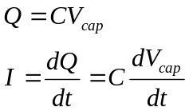 Equation (3)

Using Kirchhoff’s Voltage Law (KVL) with these equations, we derive the differential equation for the voltage across the capacitor, labeled V_{cap}, with respect to time. The V_{cap} equation models the signal transmitted over the antenna network. Through characteristic equation analysis, we determine the damping of the system. Upon solving for all necessary constants, we are left with the equation that models the key click signal. We determine the signal’s estimated pulse time through a mathematical analysis of its pulse envelope, while the center frequency is found through a capacitance-inductance relationship. Two signal-to-noise ratios are established using the 100ms pulse detector and our software patch installed on a correlation detector, respectively. A sensitivity analysis can then be drawn from our conclusions.

Switching to the CW mode for the enemy transmitter, we replace our initial voltage input (source) with an oscillator. The differential equation is resolved to account for the new circuit setup. Using the new information and through gain-frequency relationships, we determine the maximum gain of the system and its useful operational bandwidth.

Detailed Analysis

Key Click Mode

Using Kirchhoff’s Voltage Law, we use Equation (4) to model the voltage drop across the foreign radio circuit:

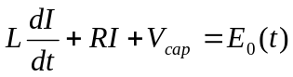 Equation (4)
Through algebraic substitution using Equations (1) – (3), we rewrite Equation (4) in terms of V_{cap}:

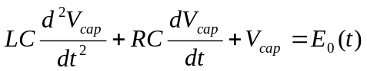 Equation (5)

Given that there was no input to the differential equation, we set it equal to zero. To arrive at Equation (6), we divide by LC to eliminate the coefficient on the highest order term:

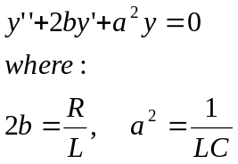 Equation (6)

We use a trivial differential solution to model the suggested output:

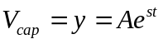 Equation (7)

Substituting Equation (7) into Equation (6) and taking all derivatives yields Equation (8), after algebraic simplification:

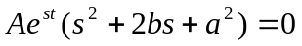 Equation (8)

With the help of the quadratic formula, we find the roots of the characteristic equation:

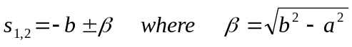 Equation (9)

Using the variable definitions from Equation (6), we know that a = 10⁷ and b = 100. With these new values, we can define the values in Equation (9) to be s =-100 ± j10⁷. These values of a and b indicate that the system is underdamped. This occurs when there is an imaginary component to the roots of the differential equation. In the case of an underdamped system when a > b:

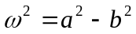 Equation (10)

Since the value of a is much greater than b, we make the approximation that ω = a. Defining β = jω with ω = 10⁷, we write the solution to the general differential equation:

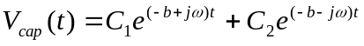 Equation (11)

The differential equation is rewritten in trigonometric form for analytical purposes:

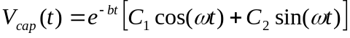 Equation (12)

We now apply the initial conditions of our system before the circuit becomes active. We know that at t = 0, there is a full 9V charge on the capacitor and that there is no current flowing through the capacitor. The following equations effectively model these conditions:

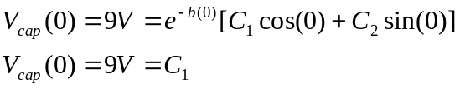 Equation (13)

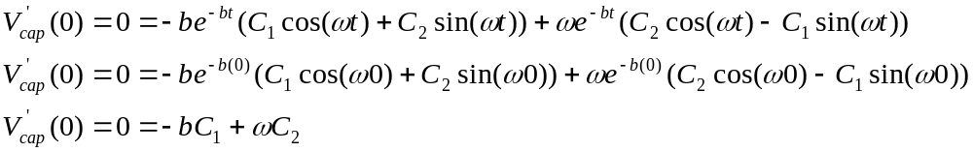 Equation (14)

Upon solving Equation (13) and Equation (14), we see that C₁=9 and C₂=9x10⁻⁵. With these newly found constants, we make the appropriate substitutions into Equation (12) to complete the differential equation:

Equation (15)

We now solve for the center frequency of the waveform the relationship established in Equation (18) for RLC circuits:
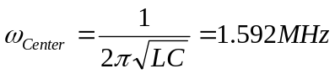 Equation (16)
In analyzing a plot of Equation (15) squared, of which the integral is signal energy, we see that the majority of the signal energy is captured within our 20ms pulse time with MATLAB:

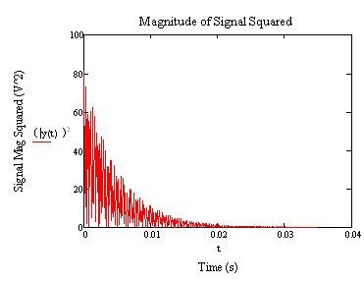

Figure (3): Magnitude of Signal Squared

This graph justifies our assumption that the majority of the signal energy is captured after a 9dB signal attenuation. A 9dB attenuation results in the signal having 12.5% of its original voltage. The pulse time can also be derived through algebraic analysis of the signal envelope:
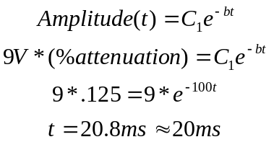 Equation (17)
In comparison to the 100ms pulse detector, our pulse time is five times shorter. With the signal to noise ratio assumed to be constant per unit time, we establish the signal to noise ratios for the 100ms pulse detector and for our correlation detector with the software patch:

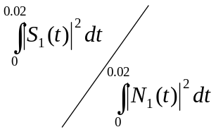 ~ signal to noise ratio using 20ms software patch. Equation (18)

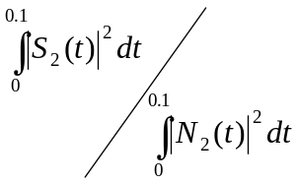 ~ signal to noise ratio using 100ms pulse detector. Equation (19)

Since almost all of the signal energy is captured within the 20ms period, we assume that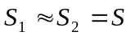. As per our assumptions, the noise is considered constant per unit time. This establishes the following signal-to-noise ratio between the correlation detector with our software patch implemented and the 100ms pulse detector:

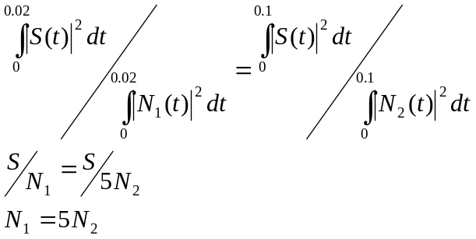 Equation (20)

The signal to noise ratio shows that a correlation detector implemented with our patch cause the system to be five times more sensitive than a 100ms pulse detector.

Given the relationship that airborne signals decay as an inverse square of the transmission radius, we determine that our signal detection radius increases by 2.24 times:

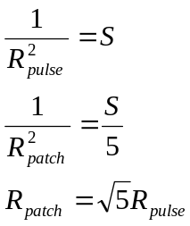 Equation (21)

Continuous Wave (CW) Mode

In CW mode, we add an oscillator to the system instead of our switch mechanism. The differential equation is redefined to account for the change:

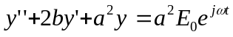 Equation (22)

Utilizing our differential trial solution of y=Ae^{jωt}, we solve for A:

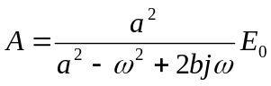 Equation (23)

Plugging back into the initial differential equation and solving for the steady-state equivalent, we find the solution:

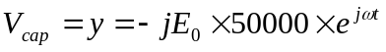 Equation (24)

The gain of the system is found by comparing the output of the system, A to its input.
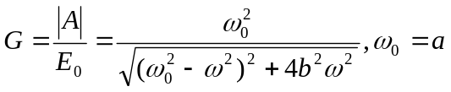 Equation (25)
The maximum gain is calculated by setting ω = ω₀, the center frequency of the system. It turns out that our G_{max} = 50,000 or 93.98 dB.
To find the bandwidth of the system, take one half of the maximum gain and resolve Equation (25). You will then find the 3dB points of the system. Solving for ω will yield the upper and lower frequency limits of the bandwidth.
To find the actual bandwidth of 55.132 Hz, we subtract the lower frequency from the upper frequency:
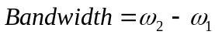 Equation (26)

Results

Results

Key Click Mode

Part | Solution
1a. | 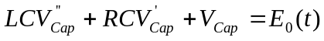→
1b. | 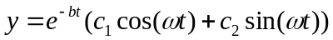 where ω = 10⁷ rad/s and b = 100 Ω/H
1c. | 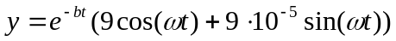where ω = 10⁷ rad/s and b = 100 Ω/H  C₁ = 9 and C₂ = 9*10⁻⁵
1d. | 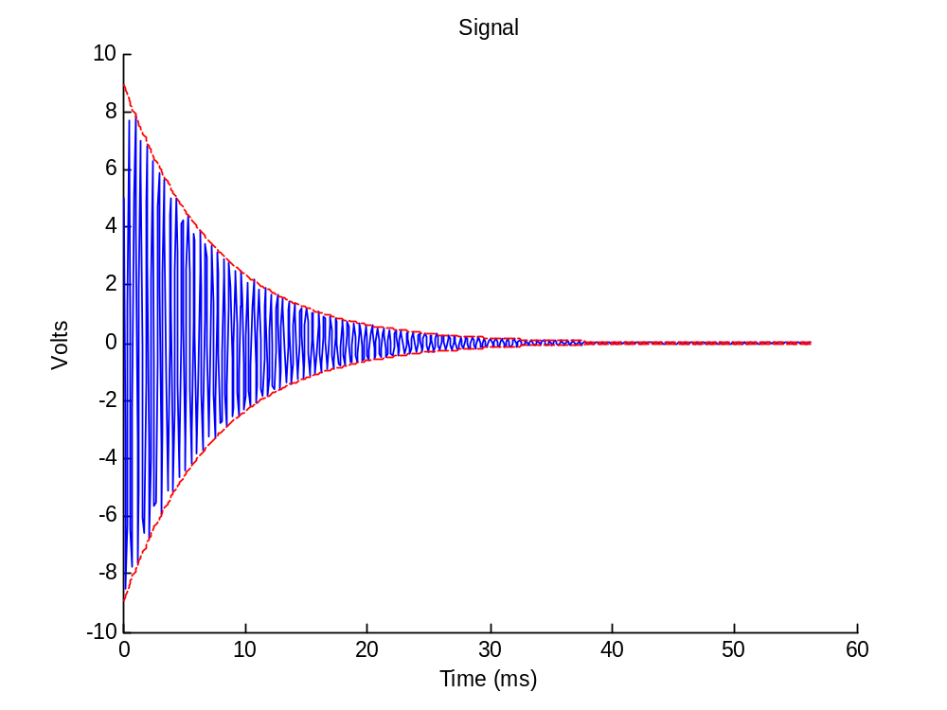
1e. | Center frequency = 1.592MHz
1f. | The characteristic pulse time is 20ms.  We chose this pulse time through MATLAB graphical analysis and mathematical analysis. It represents a 9dB drop, resulting in 12.5% of initial power.  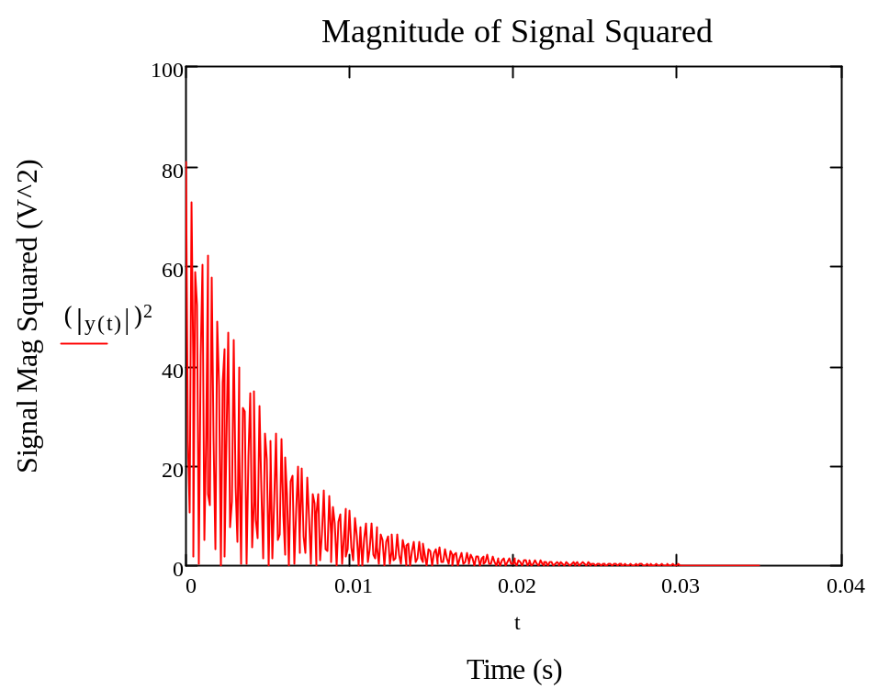  The 9dB drop in power allows us to capture the majority of the signal energy within a 20ms period. The signal energy from 0 – 20 ms and 0 – 100 ms is approximately identical. Based off this realization, we treat both signals as the same.
1g. | Our detector can sense a signal five times weaker than the 100ms pulse detector.  Our software patch increases the detection range by 2.24 times the original radius.

Table (1): Key Click Mode, Part 1 Results

Continuous Wave (CW) Mode

Part | Solution
2a. | 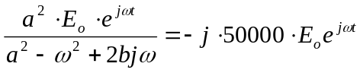 = Steady State Differential Equation  Where: 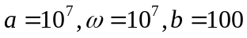
2b. | Gain = 50,000.00 or 93.98dB
2c. | 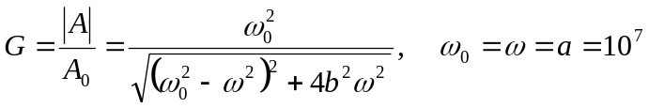 ➔ G = 50,000 or 93.98dB  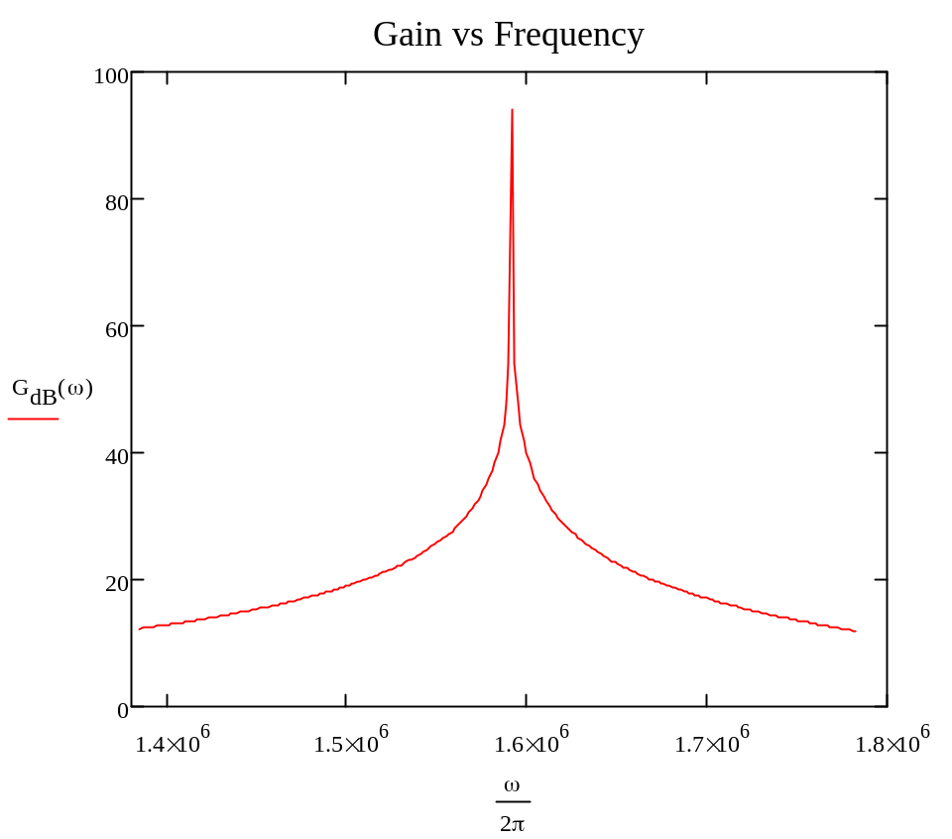  Our maximum gain occurs at a center frequency of 1.592 MHz.
2d. | G_{max}=93.98 dB (50000)  F_{center} = 1.592 MHz (1x10⁷ rad/sec)  Bandwidth = 55.132 Hz (346.045 rad/sec)

Table (2): Continous Wave (CW) Mode, Part 2 Results

Recommendations

Our software patch increases the signal sensitivity of the original 100ms pulse detector by five times. As a result, the signal detection radius increases by 2.24 times the original size.

Based on the conclusions and results our group has drawn, we fully recommend the implementation of our software patch on all existing Blackhawk surveillance receivers in an effort to successfully intercept foreign paramilitary group communication.

References

Kreyszig, E. Advanced Engineering Mathematics. New Jersey: John Wiley & Sons, 2006.

Appendix

See MATLAB and Mathcad files with report for graphical analyses and calculations.

MATLAB Code

%% MCCCXXXVII TDCI HW #1
%% Classical Solutions to Differential Equations

%%%%%%%%%%%%%%%%%%%%%%%%%%%%
% Key Click Mode - Part d) %
%%%%%%%%%%%%%%%%%%%%%%%%%%%%

%% Clear MATLAB environment of all variables and open windows.

clear all;
close all;

%% Set coefficients and equations as derived for homework assignment.

b = 100;
a = 10^7;
w = sqrt(a^2-b^2);
B = j*w;
c1 = 9;
c2 = 9*10^-5;

%% Set sampling vector 't' to iterate over 750 bins.

t = 1:750;
n = 10000;
x = t*750/10000;

%% Plot derived differential equation with respect to t
% with a sampling rate of n = 10000 per bin.

v(t) = exp(-b*t/n).*(c1*cos(w*t/n)+c2*cos(w*t/n));
hold on;
plot(x,v)
env(t) = c1*exp(-b*t/n);
plot(x,env,'r--');
plot(x,-env,'r--');
title ('Signal with Envelope');
xlabel (' Time (ms)');
ylabel (' Voltage (V)');

hold off;

